
Name: Ranjitha. R
Reg.No:192421285
Github link:
Ex: 6 Link Jira tasks with Confluence to streamline task tracking and progress monitoring for the Library Management System development
Aim: To connect Jira tasks with a Confluence project page and monitor the progress of the Library Management System.
Procedure:
1. Sign in to Jira and Confluence using the same organization account.
2. Open Jira and create or identify Library Management System tasks, such as book search, user login, database design, issue/return, and testing.
3. Record each issue key and its current status.
4. In Confluence, create a page titled “Library Management System Project Overview.”
5. Insert the Jira issues using the Jira Issues/Jira macro or issue links, as supported by the workspace.
6. Display issue keys, summaries, and statuses. Add a progress indicator if available, or calculate the completed-task percentage.
7. Publish the page and verify the issue list and progress information.
Input: Jira project and its issue keys/statuses; Confluence page title: Library Management System Project Overview.
Output: A published Confluence overview showing linked Jira tasks and their statuses, with a progress indicator.

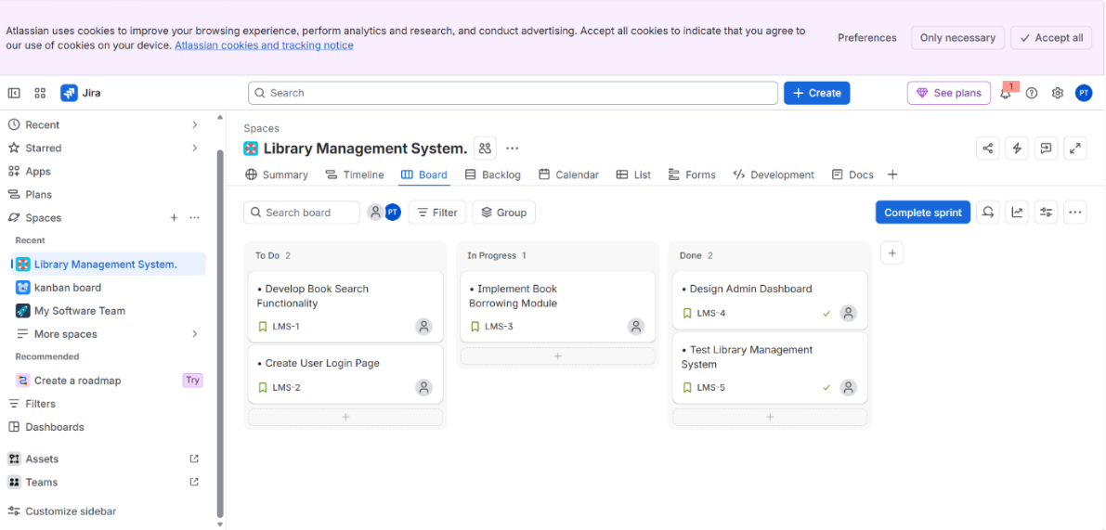
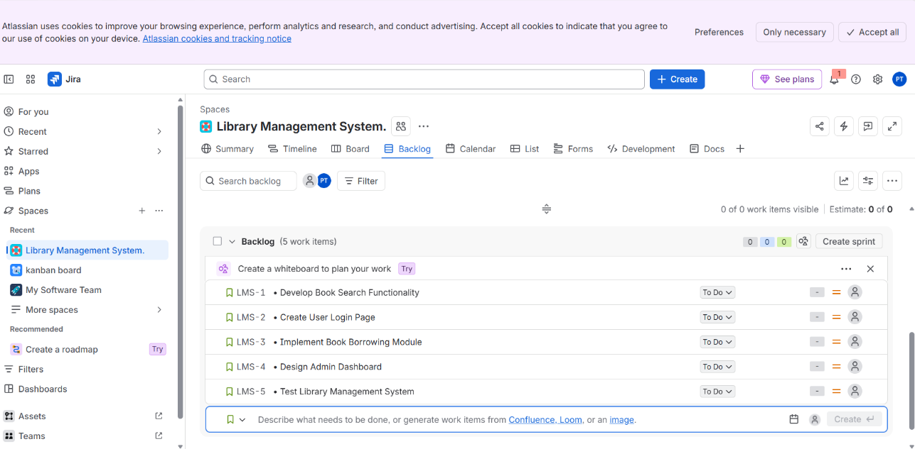

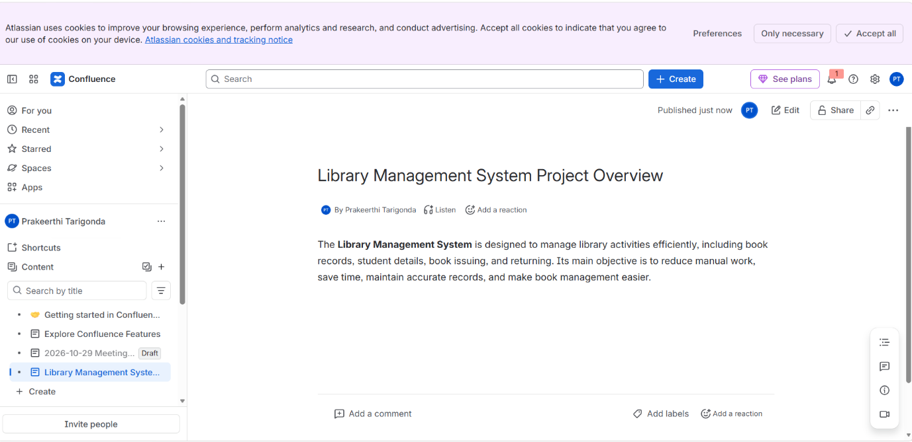
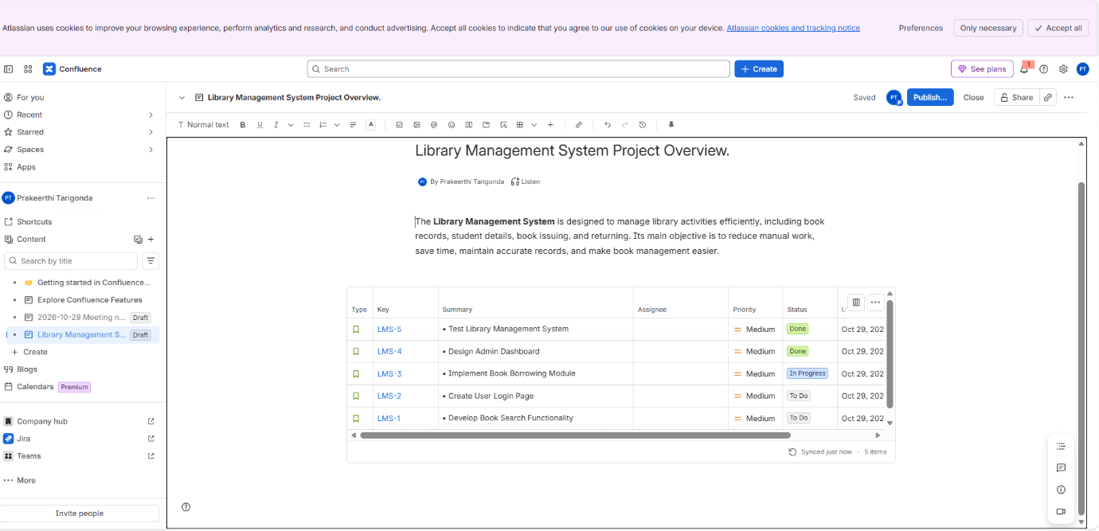
Result: Jira tasks were linked to Confluence for centralized task tracking and project progress monitoring.

Ex: 7 You are designing a Task Management System for a small team. The system should include the following features.
Aim: To plan and organize a small-team Task Management System in Jira by creating and tracking tasks.
Procedure:
1. Sign in to Jira and create a project for the Task Management System (or open the assigned project).
2. Create tasks for the required features, based on the experiment requirements in the original lab sheet.
3. Add a clear summary and description to each task; assign a team member and priority where applicable.
4. Set appropriate statuses such as To Do, In Progress, and Done.
5. Move tasks across the workflow as work progresses.
6. Review the board/list to verify task ownership and status.
Input: Task Management System requirements, team tasks, assignees, priorities, and status updates.
Output: A Jira board/list containing organized tasks with assigned owners and visible statuses.
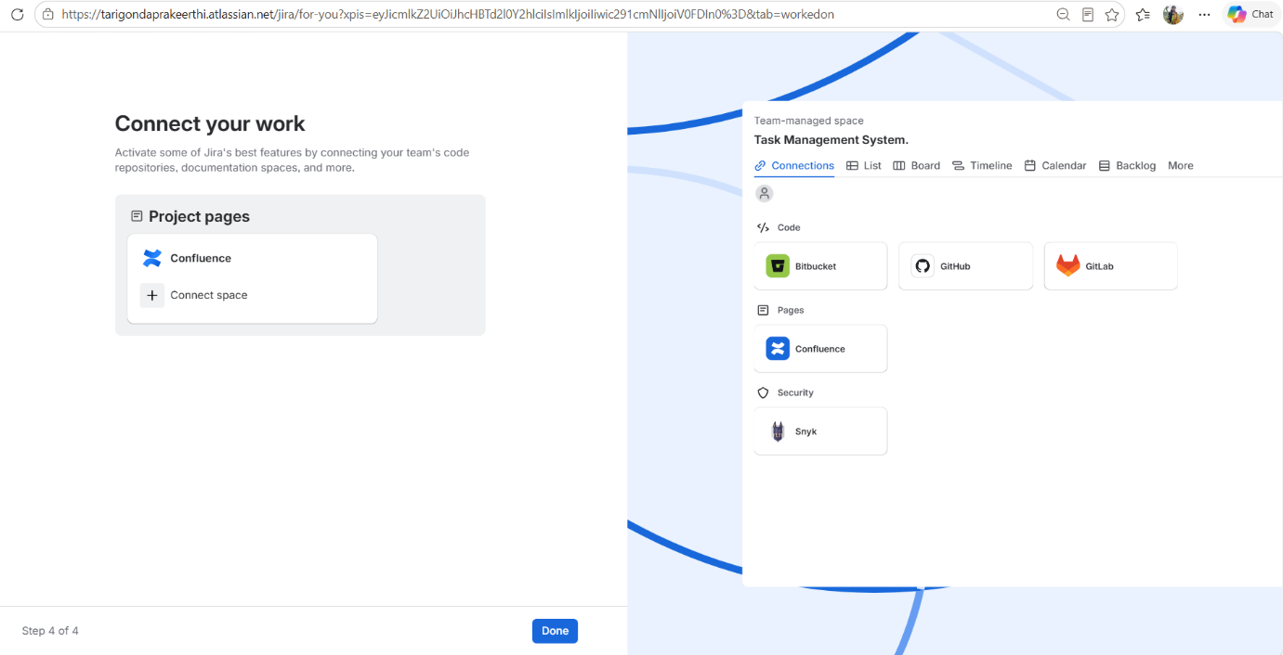
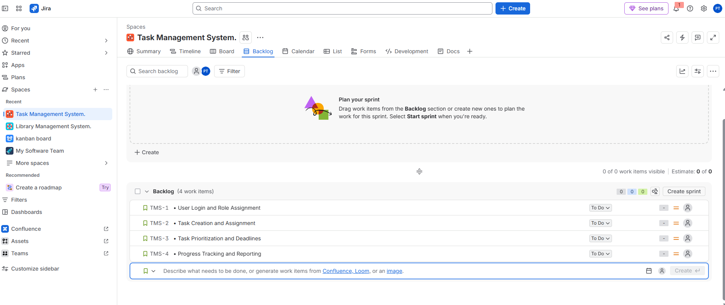
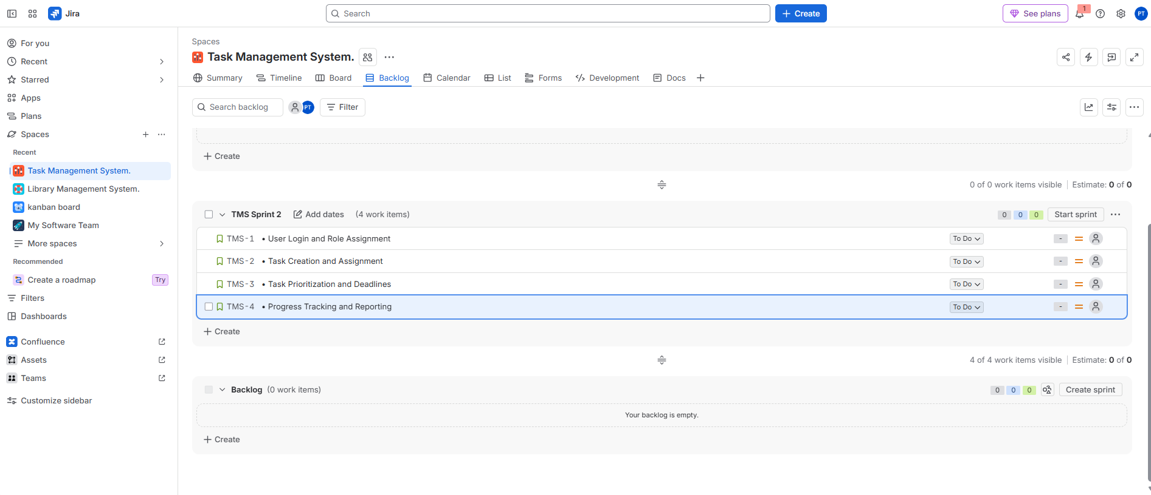
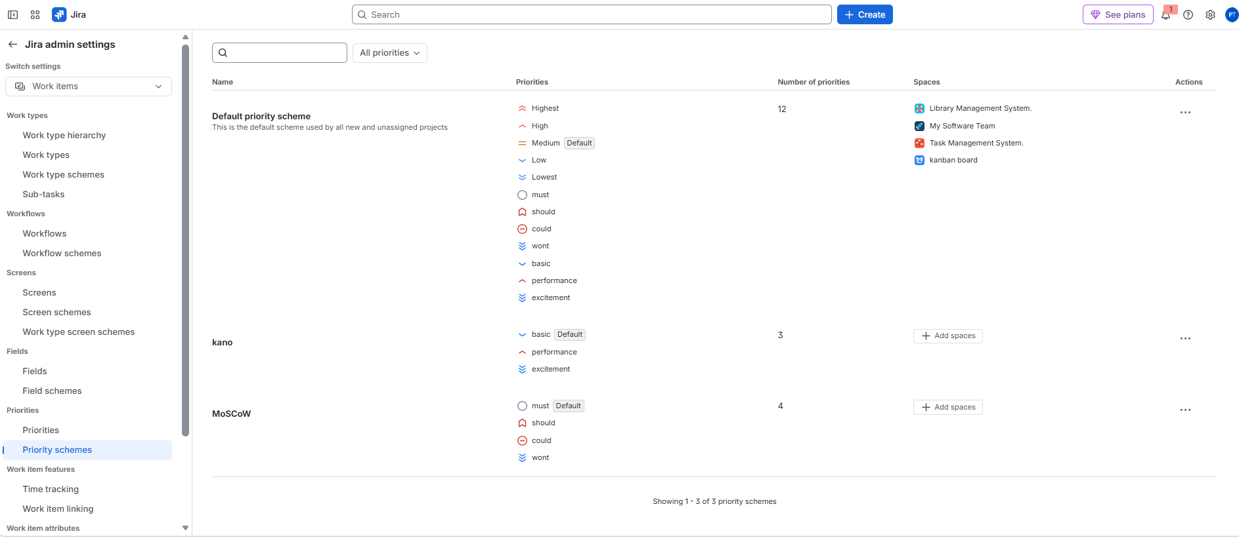
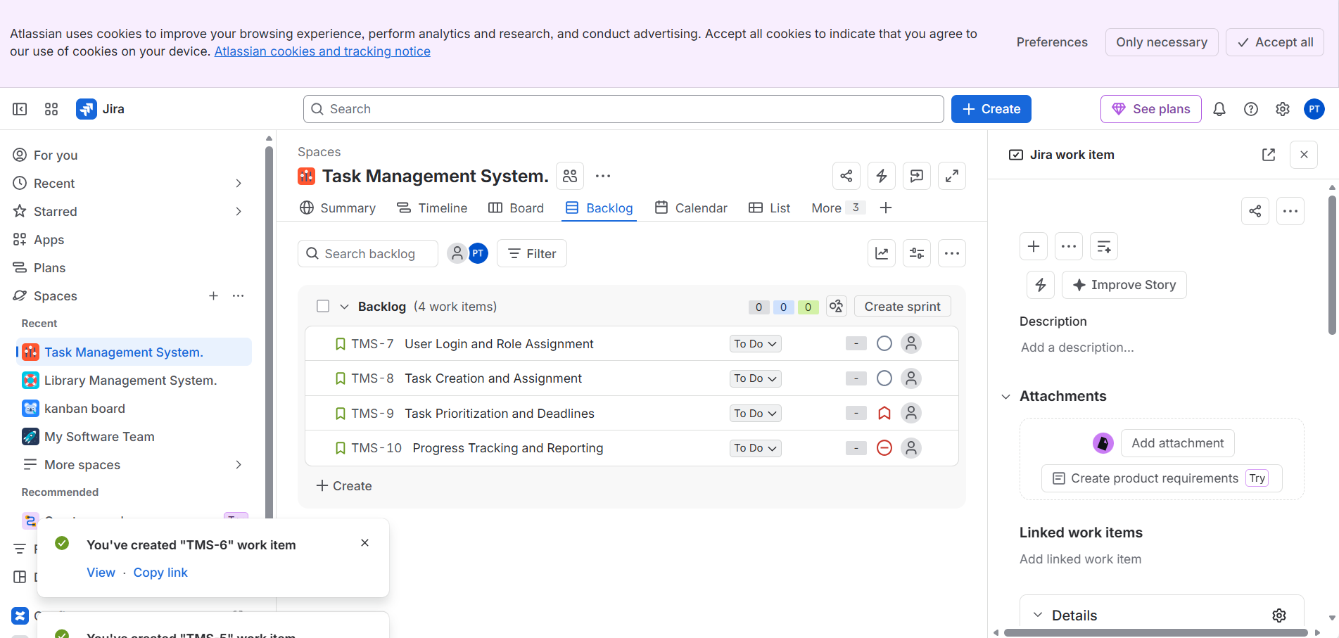
Result: The task-management work was organized in Jira, making task ownership and progress easier to monitor.

Ex: 8 You are tasked with developing an online learning Platform.The Platform should include the following functionalities. Link Jira tasks with Confluence to streamline task tracking and progress monitoring for the Library Management System development.
- Create a new page in Confluence titled "Library Management System Project Overview."
- Embed at least 5 Jira issues related to the development of the Library Management System (e.g., tasks from the sprint like "Develop book search functionality," "Create user login page," etc.).
- Use the Jira macro to display issues with status (e.g., "To Do," "In Progress," "Done").
- Add a progress bar in the Confluence page to visually track the completion of each embedded Jira task (e.g., percentage of tasks completed in the sprint).
- Submit a screenshot of the Confluence page showing the embedded Jira tasks and the progress
Aim: To track development progress using Jira tasks displayed on a Confluence page.
Procedure:
1. Create or open the Jira project containing the platform-development tasks.
2. Ensure at least five relevant Jira issues exist and have meaningful summaries and statuses.
3. In Confluence, create a page titled “Library Management System Project Overview,” as specified in the task instructions.
4. Insert at least five Jira issues using the Jira macro/issue display.
5. Show each issue’s status (for example, To Do, In Progress, or Done).
6. Add a progress bar or progress indicator. If calculated manually, use: completion % = (number of Done tasks ÷ total tasks) × 100.
7. Publish the page and capture the required screenshot.
Input: At least five Jira issue keys, issue summaries, statuses, and the total number of tasks.
Output: A Confluence page displaying at least five Jira issues, statuses, and sprint completion progress.

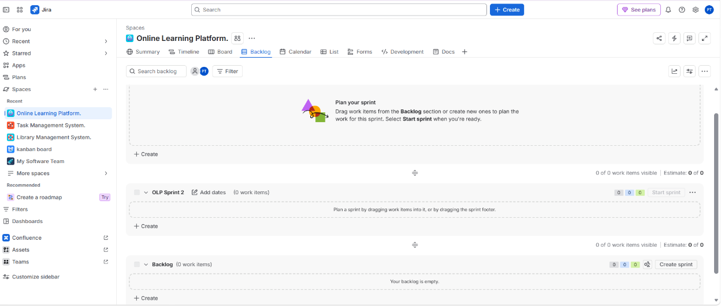

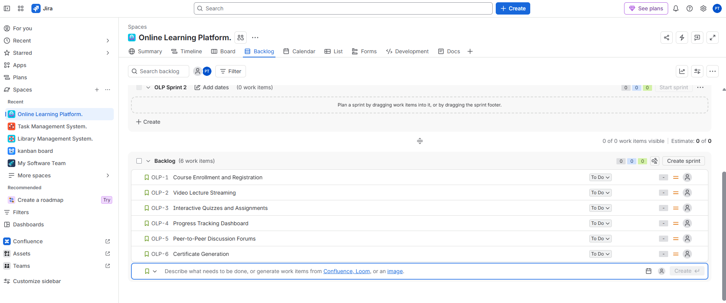
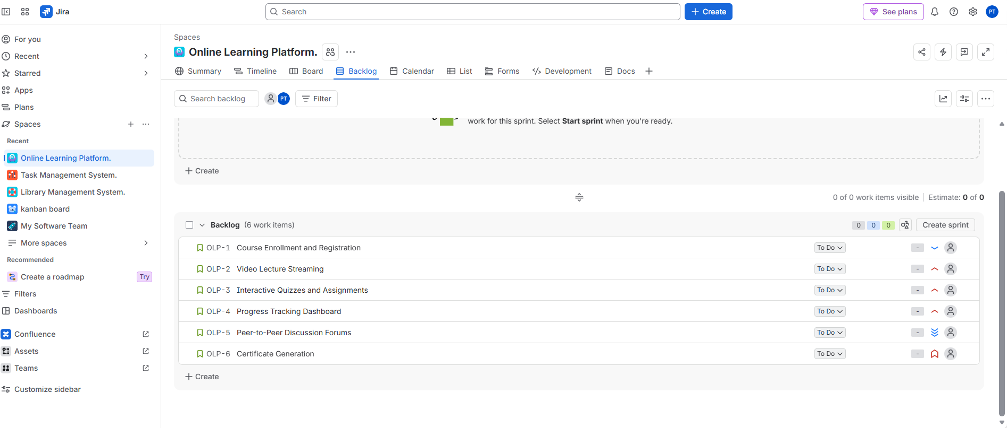
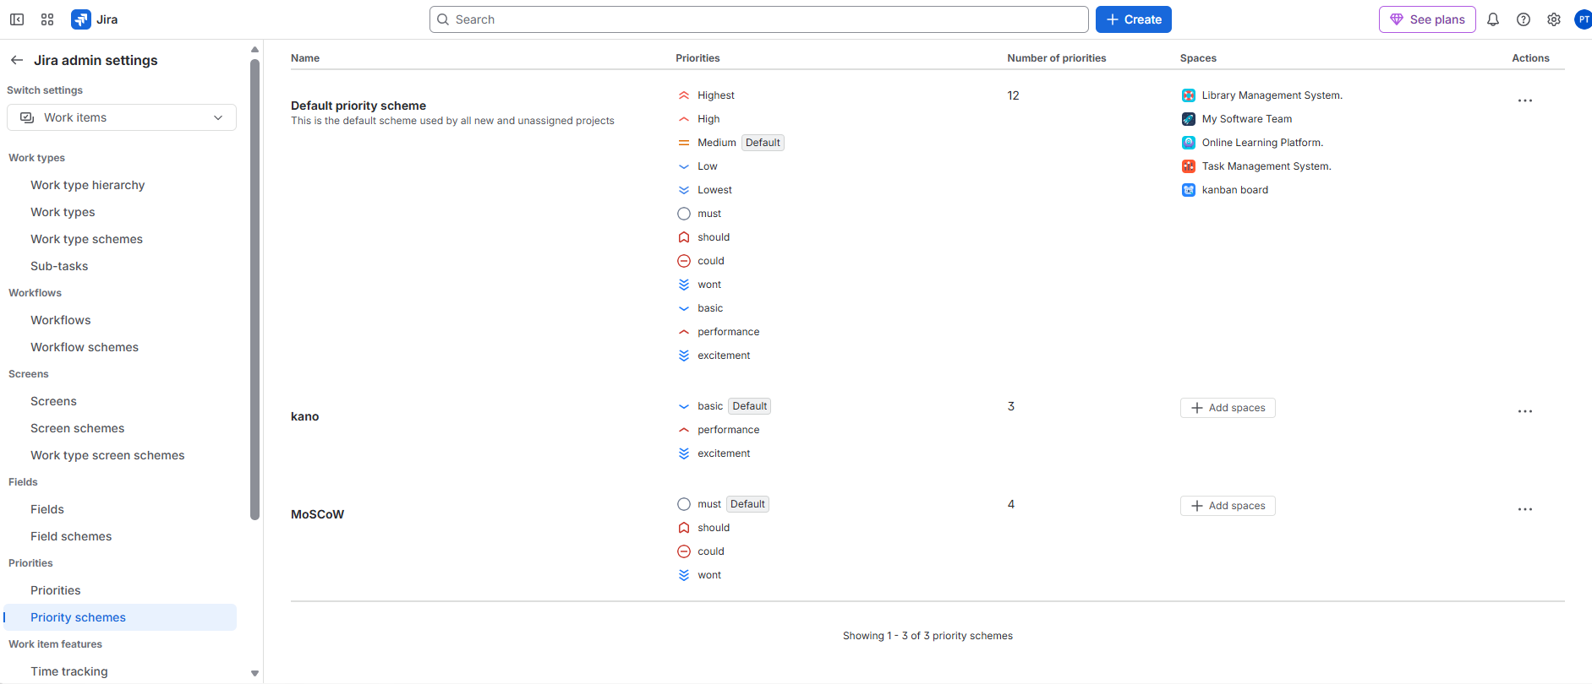
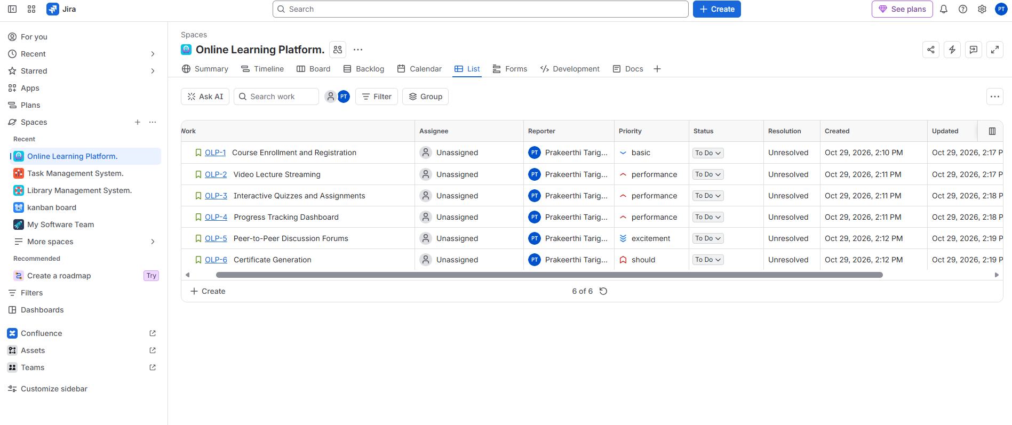
Result: The Confluence page provides a consolidated view of task status and completion progress. Note: the supplied experiment statement mentions an online learning platform but its detailed listed steps refer to the Library Management System; follow the instructor’s required project scope

Ex: 9 Demonstrate how to work collaboratively in Git/GitHub on a project using the for
and-pull request workflow.Tasks:
1. Fork an existing public GitHub repository (e.g., a sample JavaScript or Python project).
2. Clone the forked repository to your local machine using Git.
3. Create a new branch for the feature or change you want to work on.
4. Make modifications or add new features (e.g., add a function, fix a bug, or update the README).
5. Commit your changes and push the branch to GitHub.
6. Go to the GitHub repository and create a pull request to merge your feature branch into the main branch.
7. Review the pull request and provide feedback on the changes.
8. Respond to feedback by making additional commits to the feature branch if necessary.
9. Once the pull request is approved, merge it into the main branch.
10. Finally submit the link to the pull request along with a summary of the changes you made and how you collaborated.
Aim: To demonstrate collaborative development using Git and GitHub’s fork-and-pull request workflow.
Procedure:
1. Open a suitable public GitHub repository and fork it to your account.
2. Clone your fork: git clone <your-fork-URL>
3. Enter the repository: cd <repository-folder>
4. Create and switch to a branch: git switch -c feature/update-readme
5. Make a small, useful change (for example, update README documentation).
6. Stage and commit: git add . then git commit -m "Update README"
7. Push the branch: git push -u origin feature/update-readme
8. Open your fork on GitHub and create a pull request targeting the original repository’s main branch, if contribution permissions allow.
9. Review the changes and respond to any feedback with additional commits.
10. After approval, merge the pull request if authorized. Copy the pull request URL.
Input: Public repository URL, GitHub account, change to be contributed, and branch name.
Output: A pushed feature branch and a pull request link, with a summary of the contribution and collaboration.
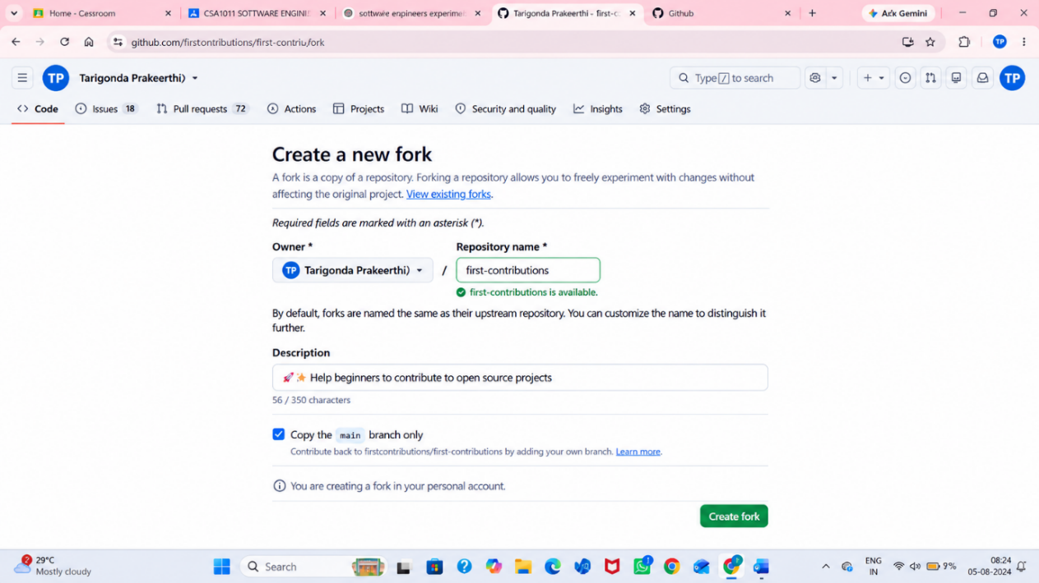
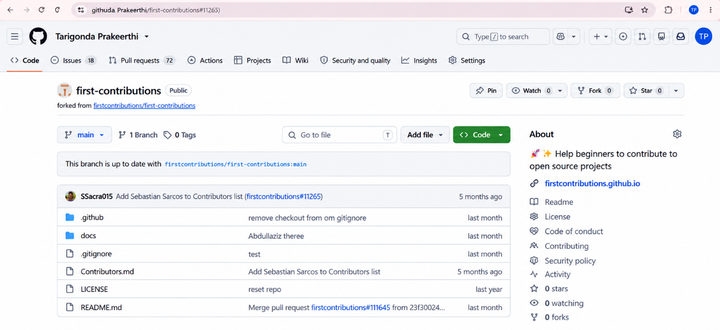
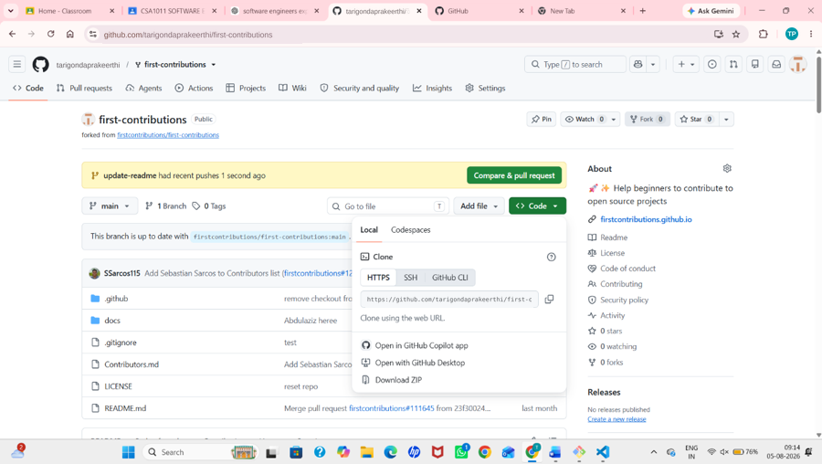
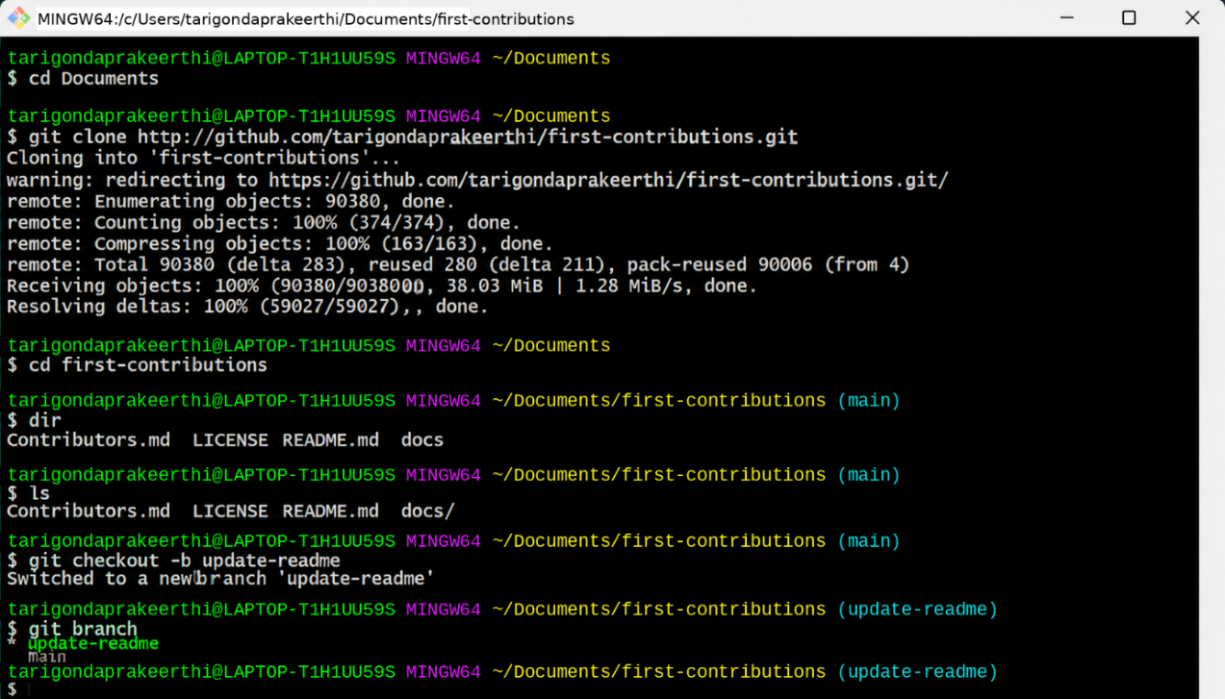
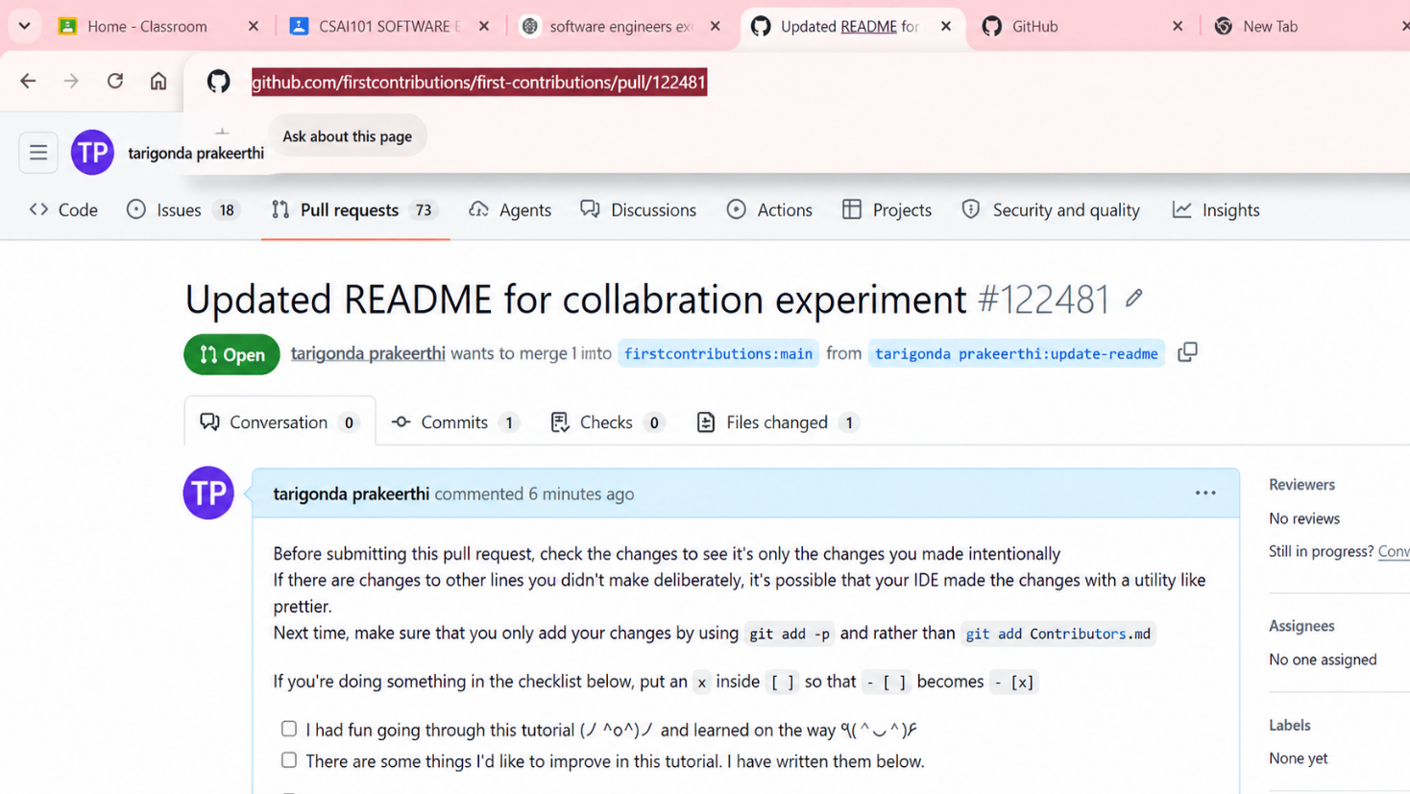
Result: The fork-and-pull request workflow was demonstrated. The pull request was submitted for review (and merged only if approval and permission were available).

Ex 10 Demonstrate how to work with Git branches and resolve merge conflicts when collaborating with others. Tasks:
1. Clone a shared repository to your local machine.
2. Create a new branch and switch to it
3. Make changes to a file (e.g., update a README or modify code in a specific function).
4. Commit your changes.
5. Push the changes to the remote repository.
6. Before merging, pull the latest changes from the main branch.
7. Switch back to your feature branch.
8. Merge the main branch into your feature branch.
9. If there are conflicts, resolve them manually by editing the conflicting files. After resolving conflicts, mark the conflicts as resolved.
10. Commit the resolved merge.
11. Push your feature branch with the merged changes to GitHub and create a pull request.
12. Submit a summary of the steps you performed, the conflicts you encountered, and how you resolved them.
Aim: To practice Git branching and resolve a merge conflict when integrating changes from the main branch.
Procedure:
1. Clone the shared repository: git clone <repository-URL>
2. Open the repository: cd <repository-folder>
3. Create a feature branch: git switch -c feature/my-change
4. Edit a file and commit: git add . then git commit -m "Add feature change"
5. Push the branch: git push -u origin feature/my-change
6. Fetch the latest remote updates: git fetch origin
7. Update local main: git switch main then git pull origin main
8. Return to the feature branch: git switch feature/my-change
9. Merge main: git merge main
10. If a conflict occurs, open the conflicted file and resolve the conflict markers (<<<<<<<, =======, >>>>>>>), keeping the correct combined content.
11. Stage and complete the merge: git add <conflicted-file> then git commit -m "Resolve merge conflict"
12. Push the updated branch: git push
13. Create a pull request and record the conflict and resolution summary.
Note: A conflict occurs only when changes overlap. If Git reports no conflict, document that no conflict occurred; do not claim one was resolved.
Input: Shared Git repository, feature-branch changes, and updated main-branch changes (overlapping edits may be needed to demonstrate a conflict).
Output: An updated feature branch with merged changes, plus a pull request and conflict-resolution summary.
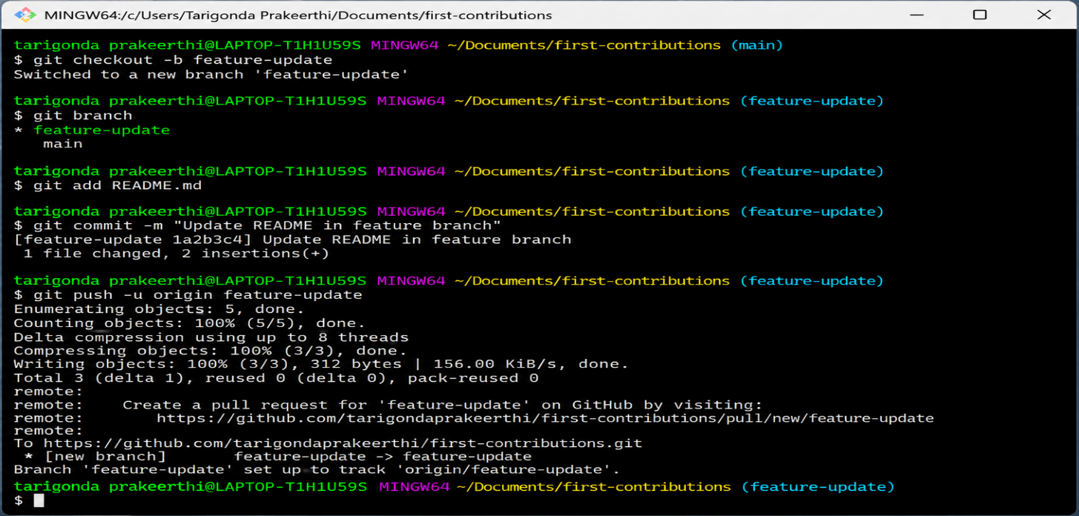
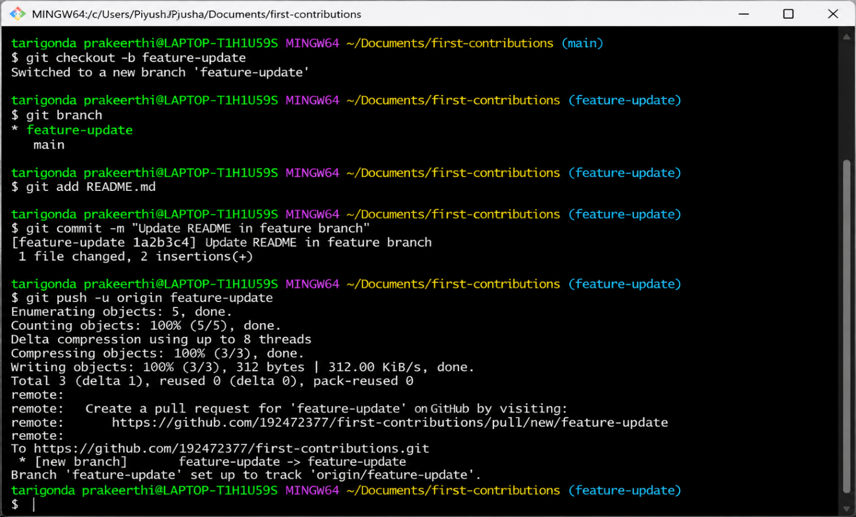
Result: Git branching and integration were practiced. Any merge conflict was resolved and committed, or the absence of a conflict was recorded accurately

